**Lesson 6 Demo 1**

**Create a New Jenkins Job to Checkout Source Code From Git Repository**

Steps to be followed:

1. Log in to Jenkins CI tool and create new Jenkins Job
2. Configure Source Code Management section for checking out source code from repository

**Step 1: Log in to Jenkins CI Tool and create a new Jenkins Job.**

1. Login to Jenkins CI tool with admin user and click on New Item to create a new Jenkins’s job.

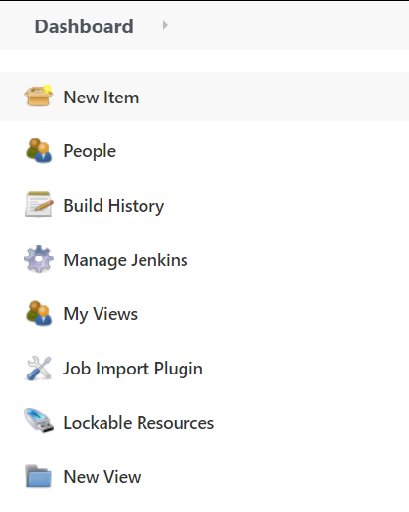

1. Select Freestyle project while creating Jenkins’s job and provide custom job name.

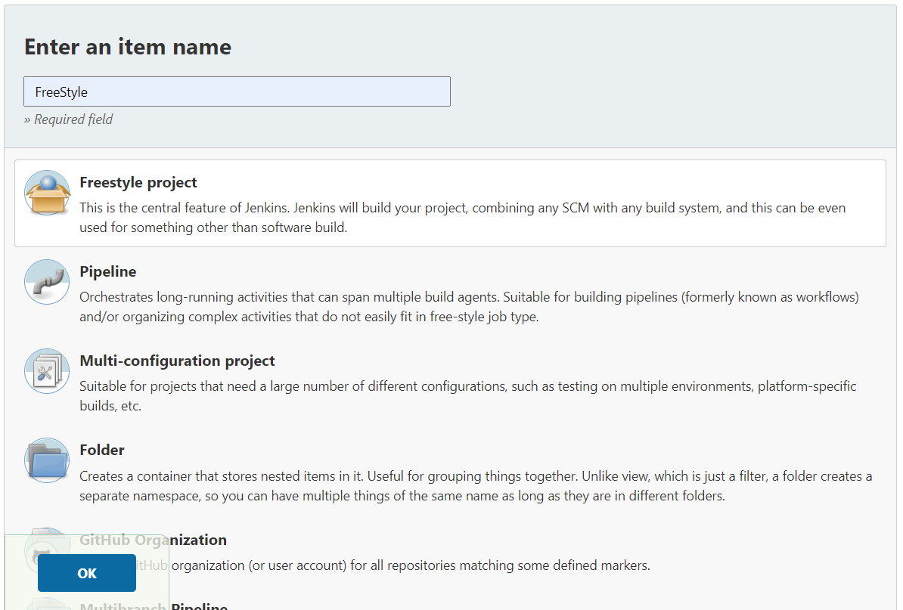

1. Once the job name is provided, click on Ok button to save Jenkins’s job and a new configuration screen would be opened.

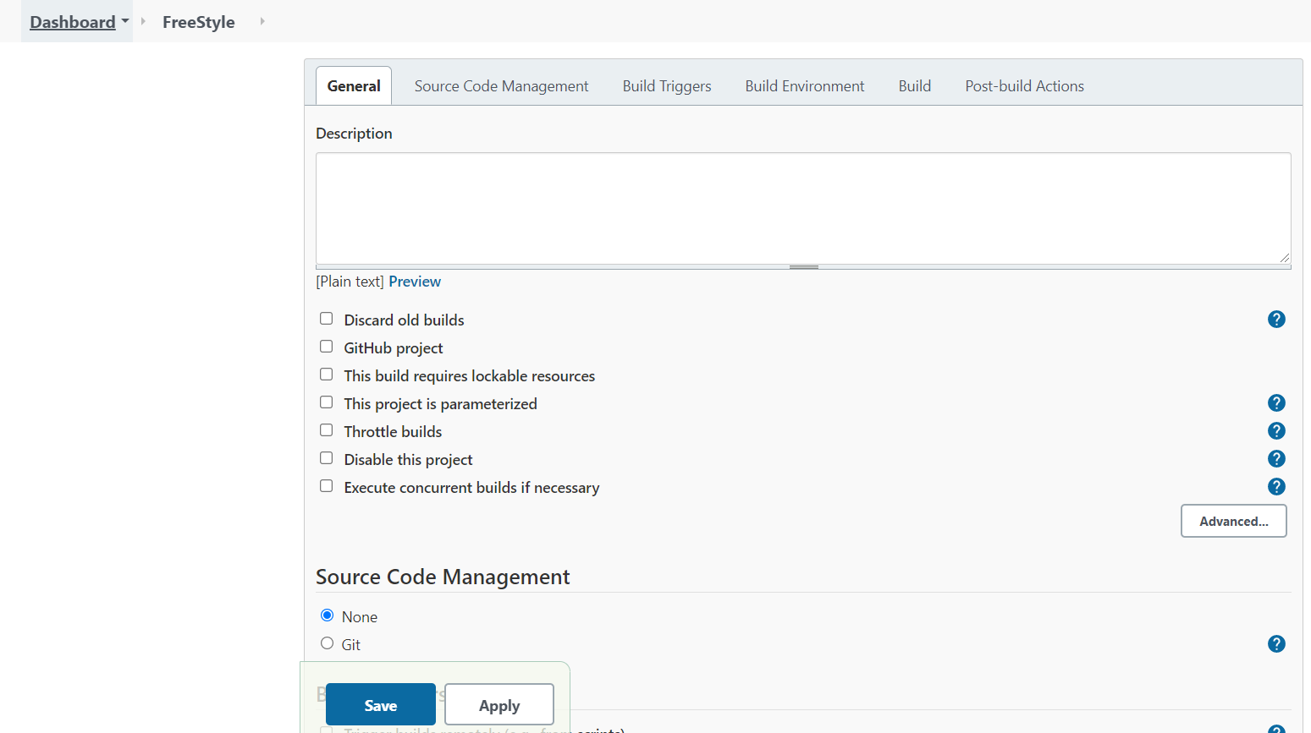

1. In the configure screen, you need to access **Source Code Management** tab to provide Git repository configurations.

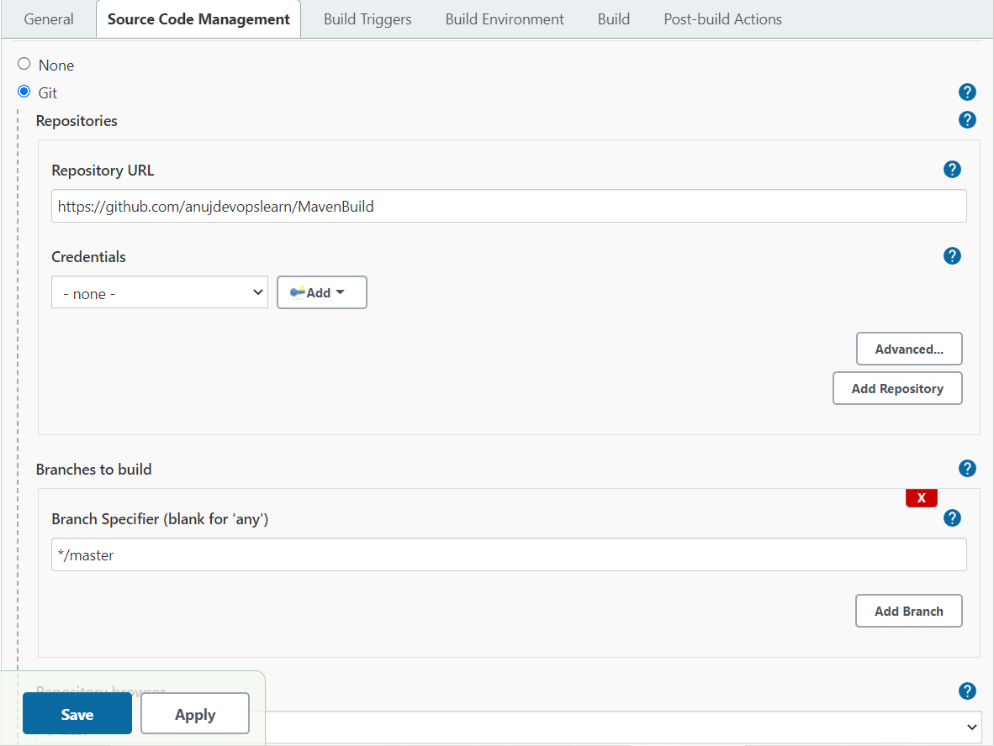

1. Once Git repositories configurations are configured in Jenkins’s job, you can save these configurations in Jenkins.

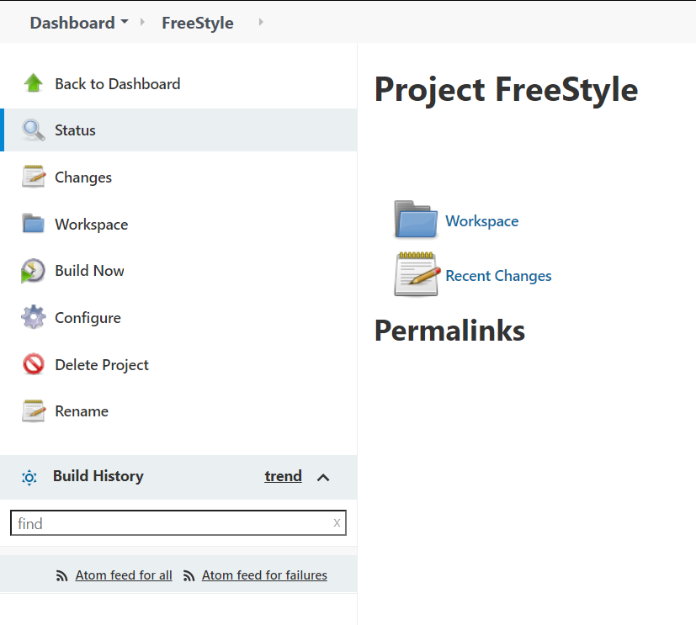

**1.6** Then Click on Build Now option to trigger new build and build logs will show the code check out process during the build process.

